INVENTORY LAB MODULE ANSWERS:
PRABHJEET SINGH

USE CASE DIAGRAM
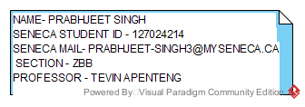
CLASS DIAGRAM
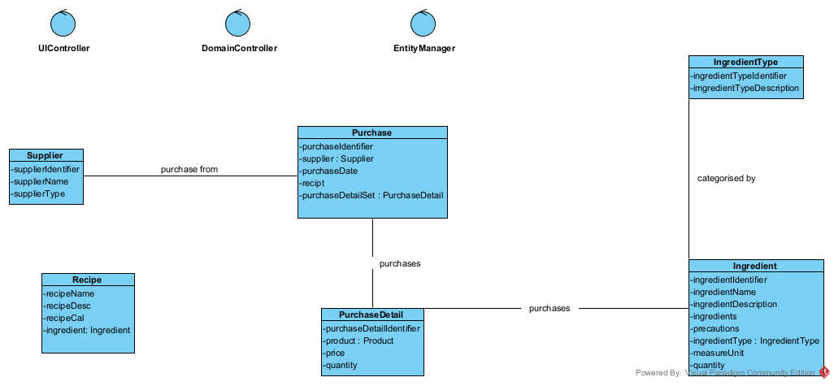

SEQUENCE DIAGARM

Create Ingredient Information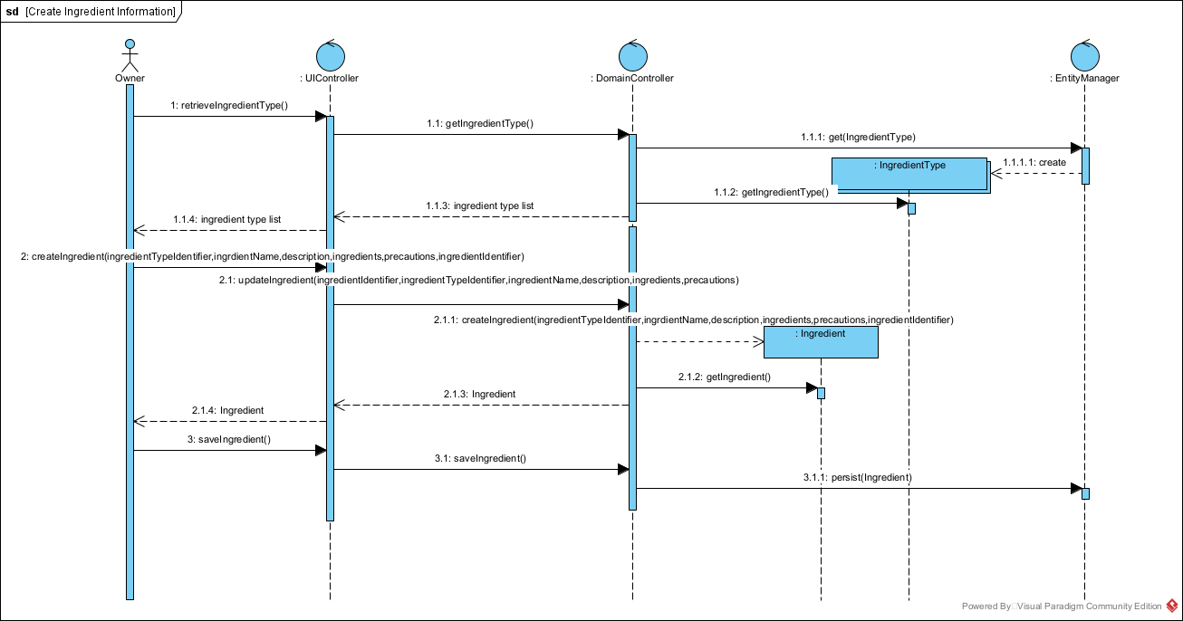
Create a recipe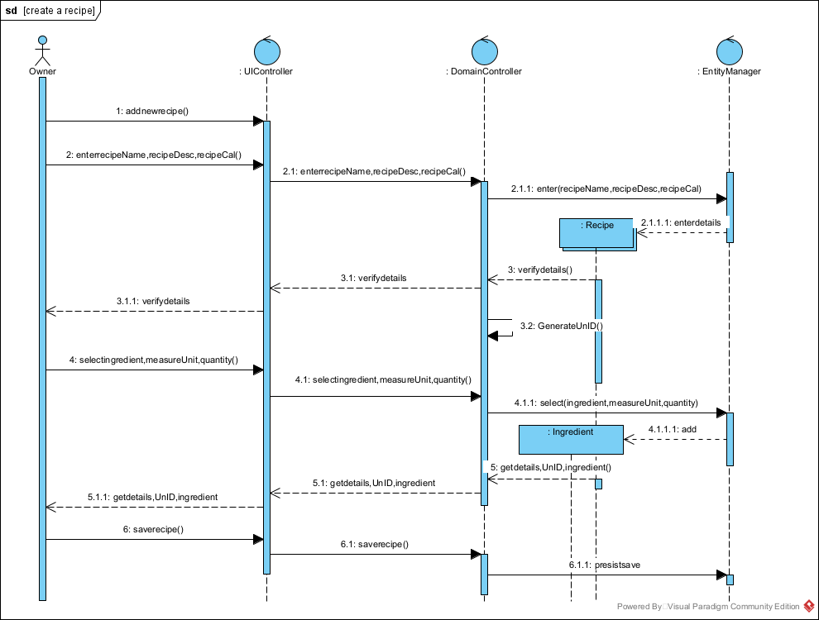querypurchase
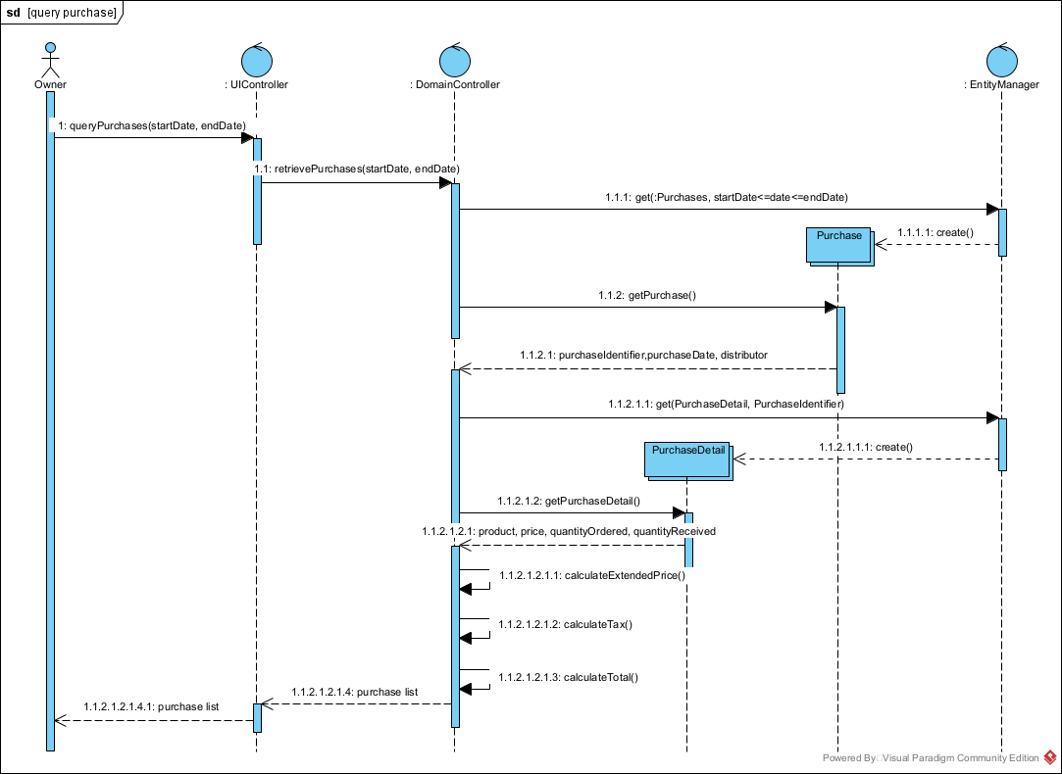

queryrecipe

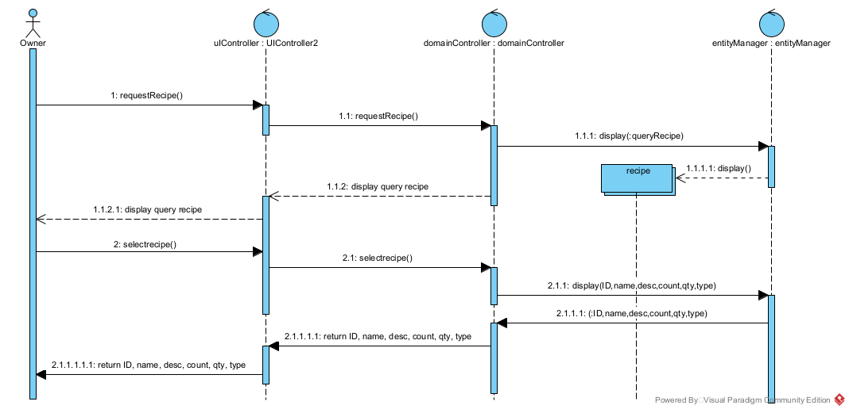

create purchase
